**Custom Offer Requirements.**

Use an internet browser with automatic translation, e.g. Google Chrome.

All the content will be automatically translated in English if the website is not English.

Also you must provide a original website language version.

**You must provide a tutorial in PDF how to use the code and the libraries that were necessary to extract such data and provide full support until I start the scarping procedure in my PC.**

**All fields data are required.**

**For example, if the e-mail field exist then the e-mail must be extracted if the phone field exist, the phone number must be extracted too, address, faxes, special observations… and so on........ if a field data exists, you have to extract such data.**

Seller must provide an Excel file with xlsx extension for each link with the full data requested for all the entries that contain each link, despite the Buyer will run or will do a simulation to test the script.

Excel file must have the country name if is just one link and if there are many, URL link will be the name for each file.

The phone numbers must be extracted and prepared in international format, meaning the country coude starting with the sign + and must not contain any sign of punctuation as round brackets (), hyphens -, full points, comma or other similar signs.If in the original source the phone number contain a 0, this must be eliminated when you will add the international code.**The phone numbers must be ready to be dialed or must be ready to send to them a SMS. The same for the fax numbers, they must be ready to be used.**

**Therefor, once you have the data in Excel, please clean it up, eliminate the brackets, commas, lines, points, spaces…and so on, prepare the mobile phone numbers as you want to send them a TEXT message.**

WARNING:

If are detected that 5 emails were not extracted per link and I can prove it and if there are more than 5 phone numbers that are not prepared as explained above, ORDER will be cancelled.

Duplicate lines must be eliminated in the Excel files.

Seller must give proof of work each time the buyer request it. Seller will start to work straight away for the Buyer and video proof or pictures can be requested as proof that the Seller is working on the GIG.

# import scrapy

# from scrapy.http import Request

# class TestSpider(scrapy.Spider):

#     name = 'test'

#     start_urls = ['https://www.ifep.ro/justice/lawyers/lawyerspanel.aspx']

#     custom_settings = {

#         'CONCURRENT_REQUESTS_PER_DOMAIN': 1,

#         'DOWNLOAD_DELAY': 1,

#         'USER_AGENT': 'Mozilla/5.0 (X11; Linux x86_64) AppleWebKit/537.36 (KHTML, like Gecko) Chrome/79.0.3945.130 Safari/537.36'

#         }

#     def parse(self, response):

#         books = response.xpath("//div[@class='list-group']//@href").extract()

#         for book in books:

#             url = response.urljoin(book)

#             if url.endswith('.ro') or url.endswith('.ro/'):

#                 continue

#             yield Request(url, callback=self.parse_book)

#     def parse_book(self, response):

#         title=response.xpath("//span[@id='HeadingContent_lblTitle']//text()").get()

#         d1=response.xpath("//div[@class='col-md-10']//p[1]//text()").get()

#         d1=d1.strip()

#         d2=response.xpath("//div[@class='col-md-10']//p[2]//text()").get()

#         d2=d2.strip()

#         d3=response.xpath("//div[@class='col-md-10']//p[3]//span//text()").get()

#         d3=d3.strip()

#         d4=response.xpath("//div[@class='col-md-10']//p[4]//text()").get()

#         d4=d4.strip()

       # det=response.xpath("//div[@class='col-md-12']//text()[3]").get()

        # print(det)

        # dot=response.xpath("//span[@class='padding-right-md text-primary']//text()").get().replace(".","")

        # print(dot)

#         yield{

#             "title1":title,

#             "title2":d1,

#             "title3":d2,

#             "title4":d3,

#             "title5":d4,

#     }

1.<https://rejestradwokatow.pl/adwokat>

select the 3 options below, or select the maximum options( to the right there are many options too) to output the maximum records.

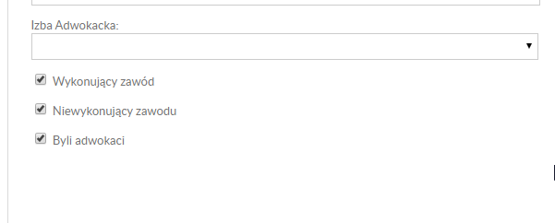

2.<https://www.aeafa.es/asociados.php>

3.<https://www.consiglionazionaleforense.it/web/cnf/ricerca-avvocati>

Selectcities:

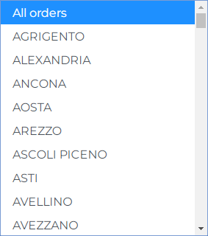

For example Rome, 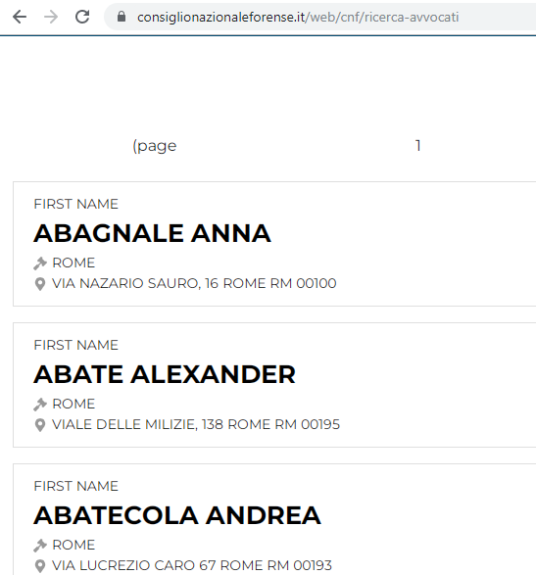

Click on the first result:

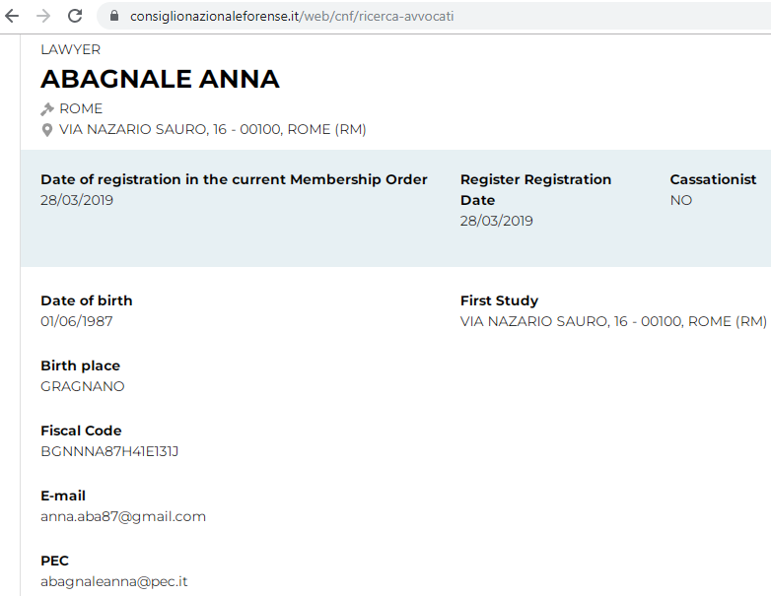

Those above are the fields.

The results from all the cities are required.

4.<https://zoekeenadvocaat.advocatenorde.nl/>

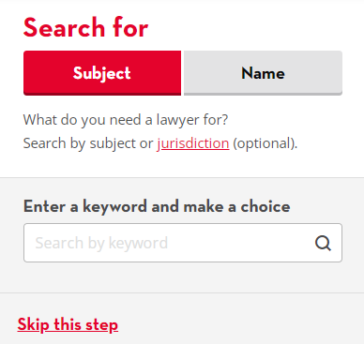

Click “Skip this step”

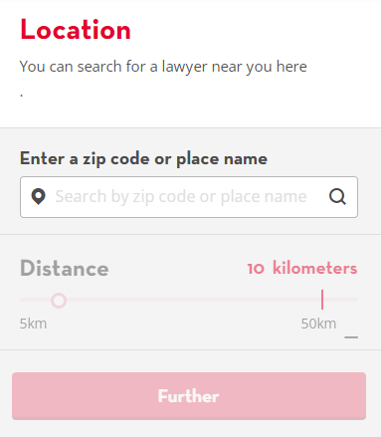

Input for example the capital AMSTERDAM and set the distance to maximum.

All cities of Holland must be inserted to get all the database.

5.<https://www.baroul-bucuresti.ro/tablou-definitivi>

6.https://www.baroul-cluj.ro/tabloul-avocatilor/avocati-definitivi/

7.<https://baroul-timis.ro/tabloul-avocatilor/>

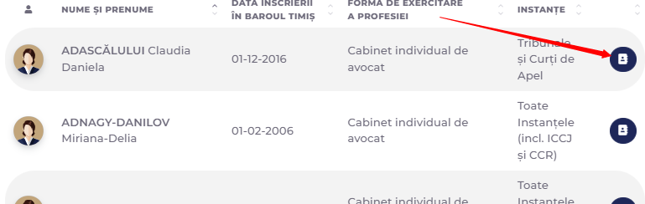

Fields:

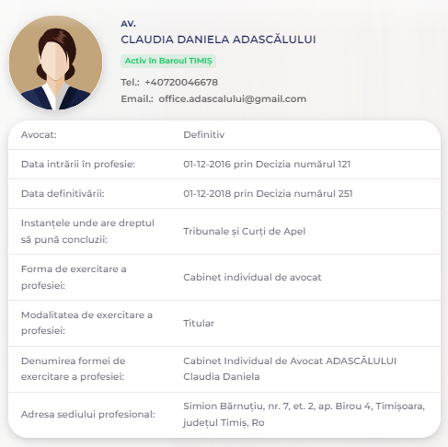

8.<https://www.baroulconstanta.ro/tabloul-avocatilor/avocati-definitivi/>

9.<https://www.ifep.ro/justice/lawyers/lawyerspanel.aspx>

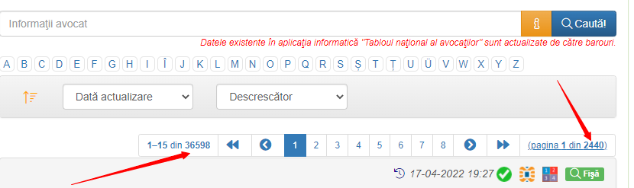

10.<https://www.bea-brak.de/bravsearch/result.brak>